**A CRM Application to Handle the Clients and their property Related Requirements**

**Create a Jotform and integrate it with the org to create a record of customers automatically.**

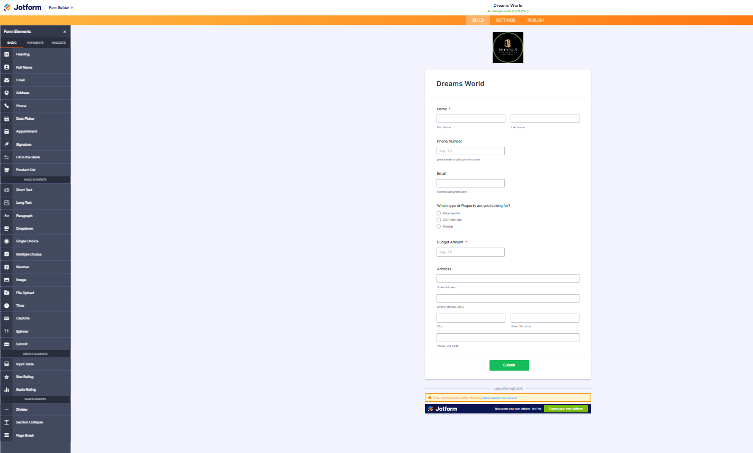

**Create Objects from Spreadsheet**

**Creating Customer Object :**

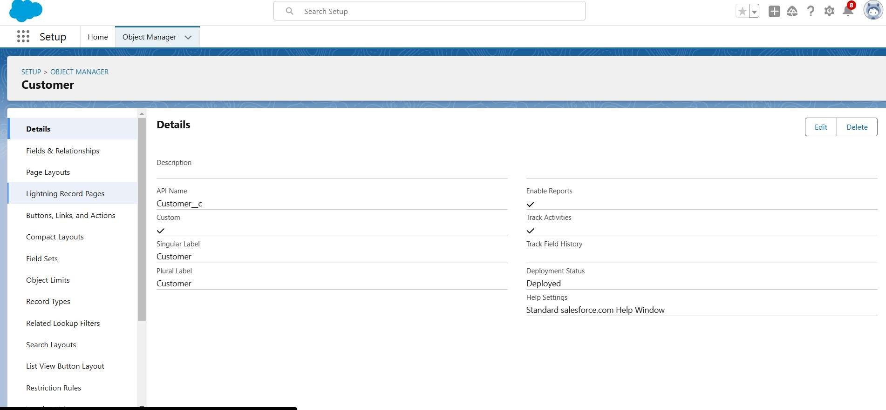

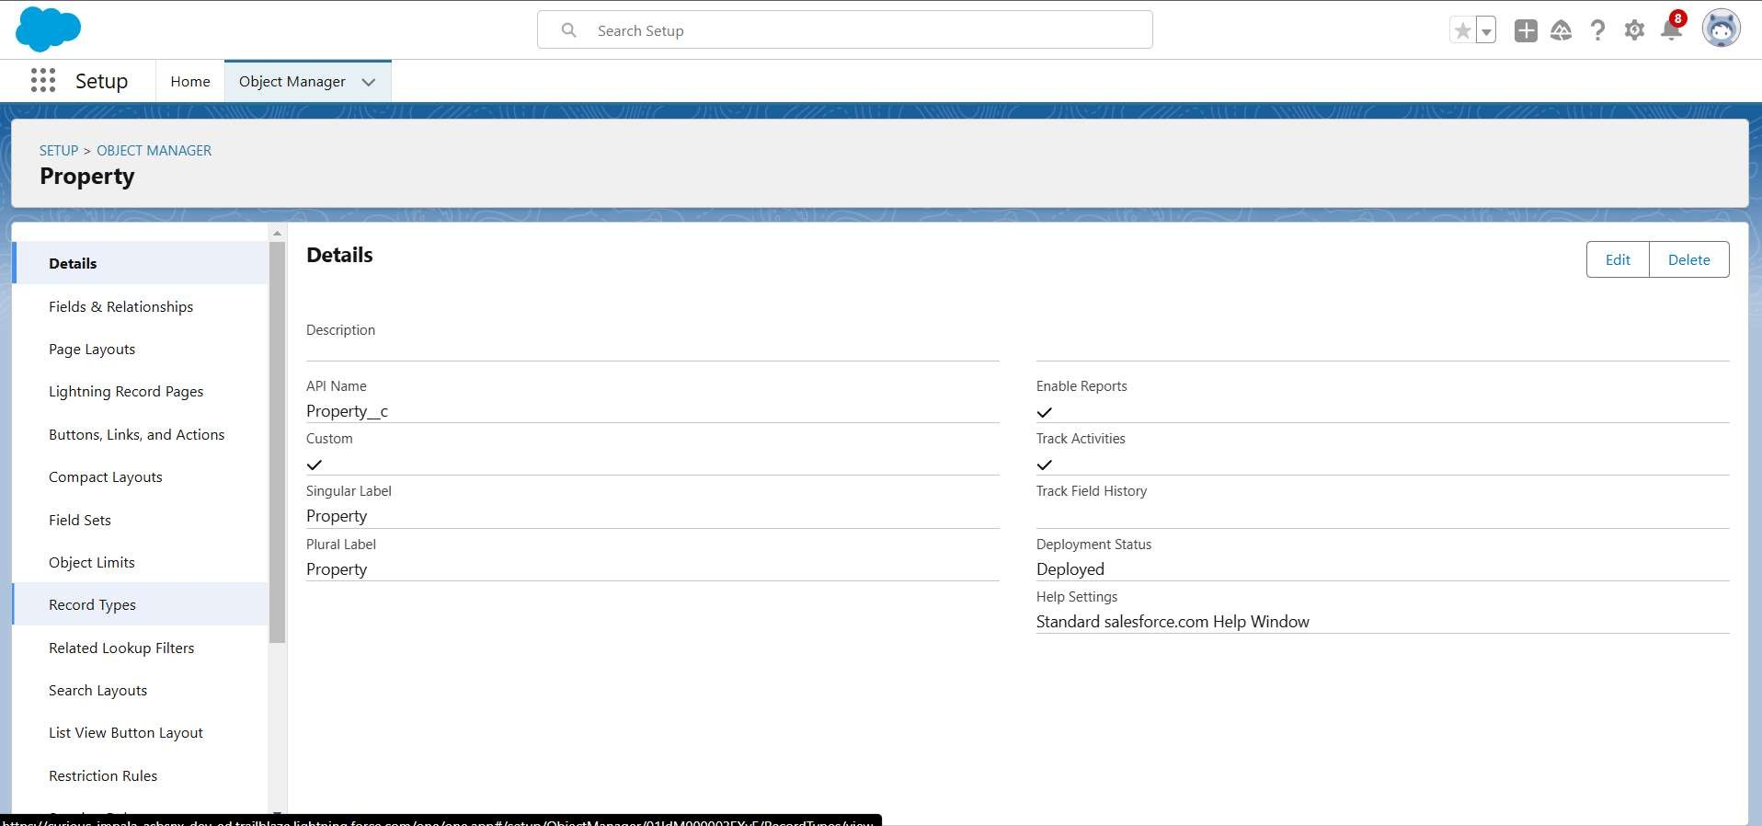**Creating Property Object :**

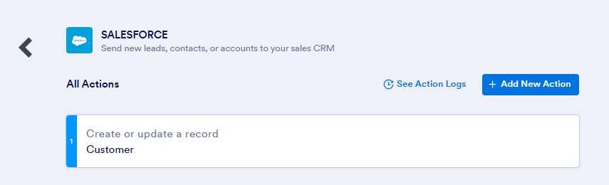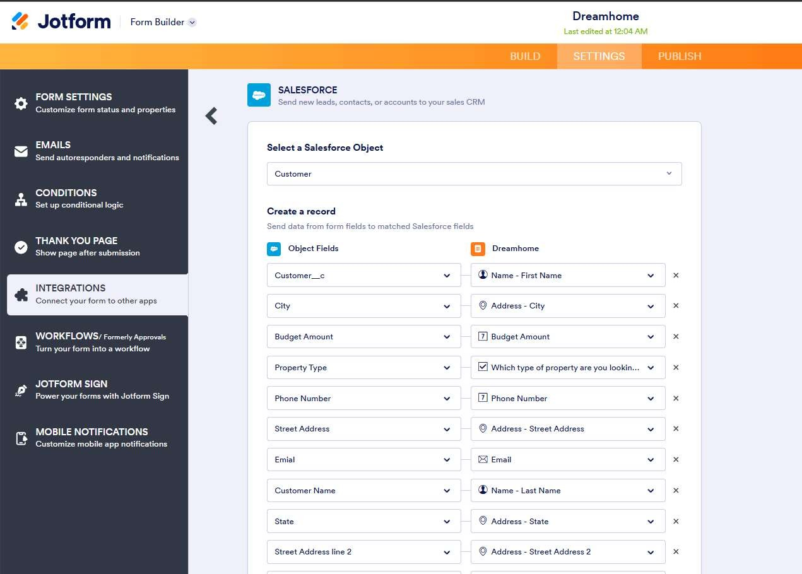**Integrate Jotform with Salesforce Platform**

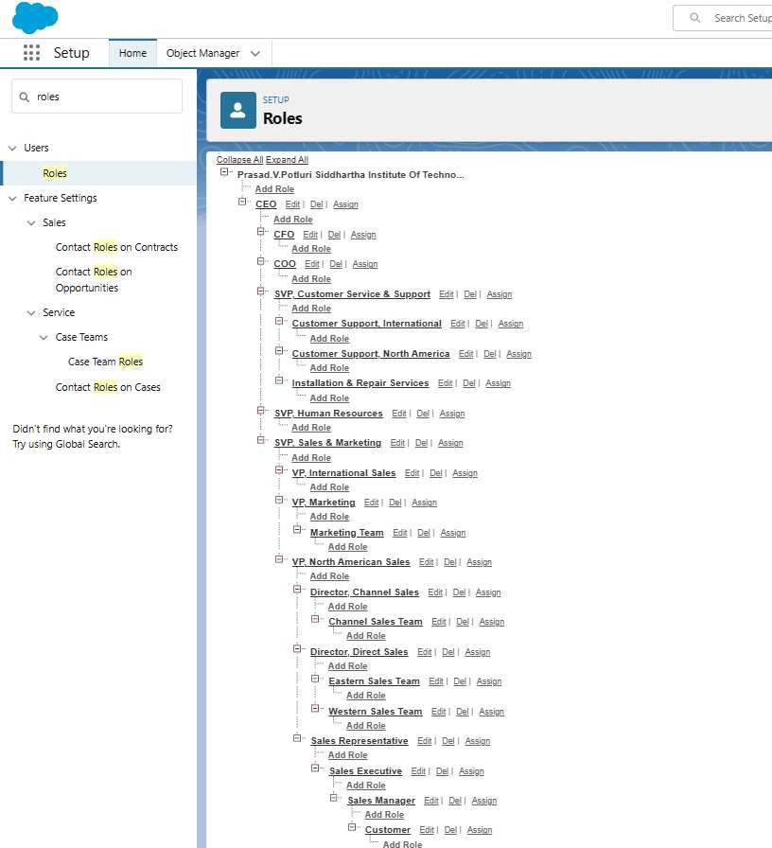**Create Roles**

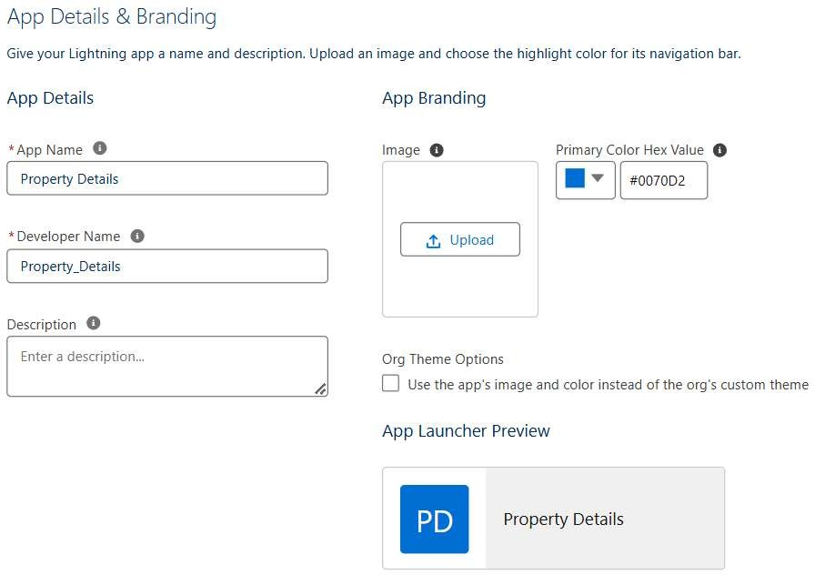**Create a Property Details App**

**Create Profiles**

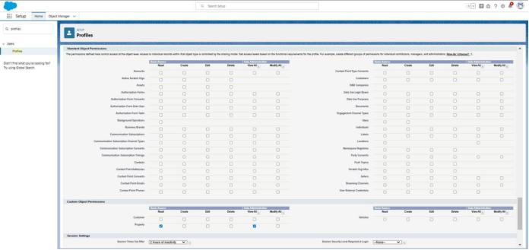**Creating Customer Profiles**

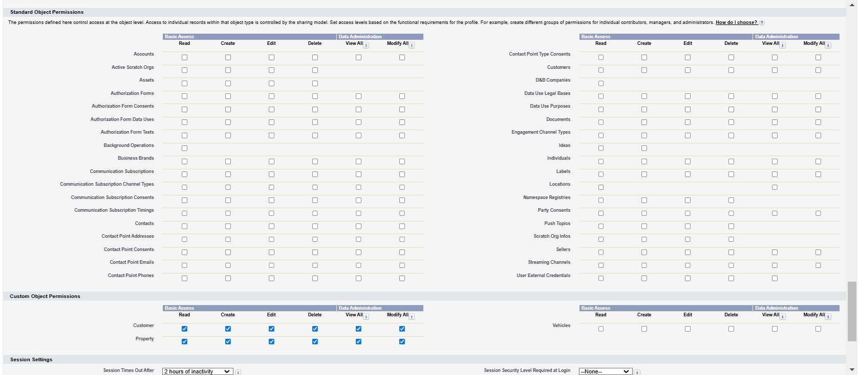**Creating Manager Profiles**

**Create a Check Box field on user**

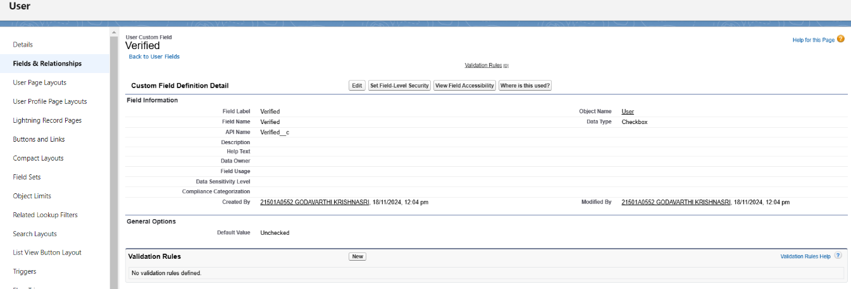

**Create Users**

**User : 1**

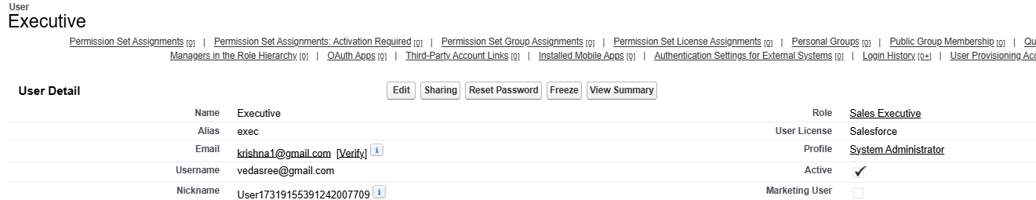

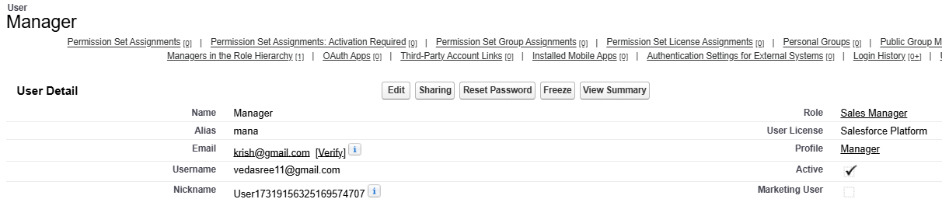**User : 2**

**User : 3**

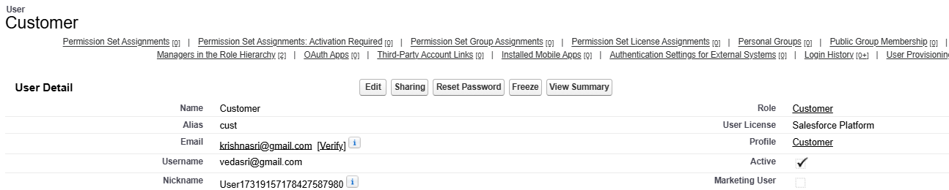

**User : 4**

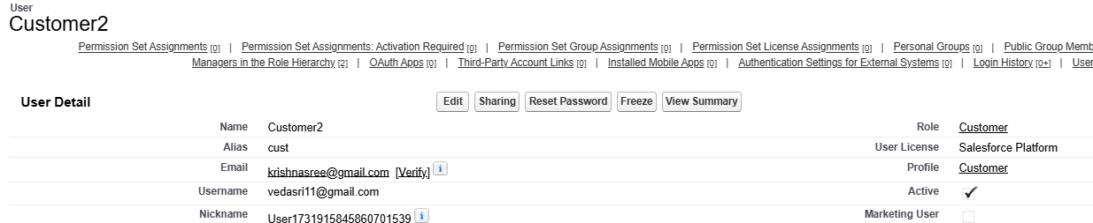

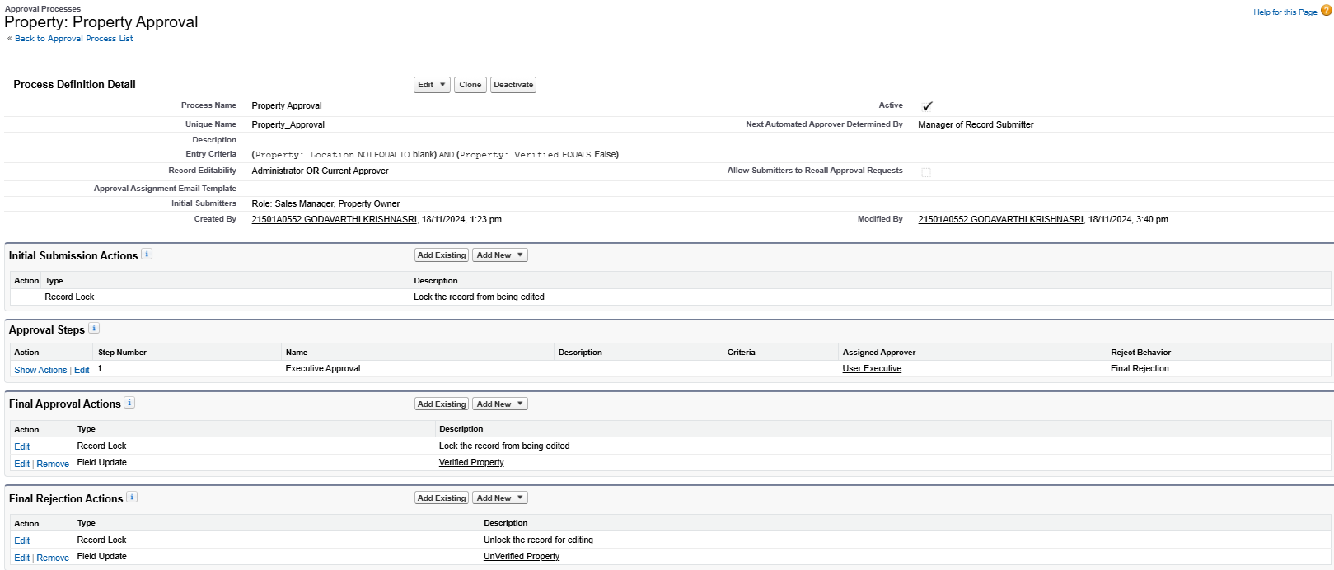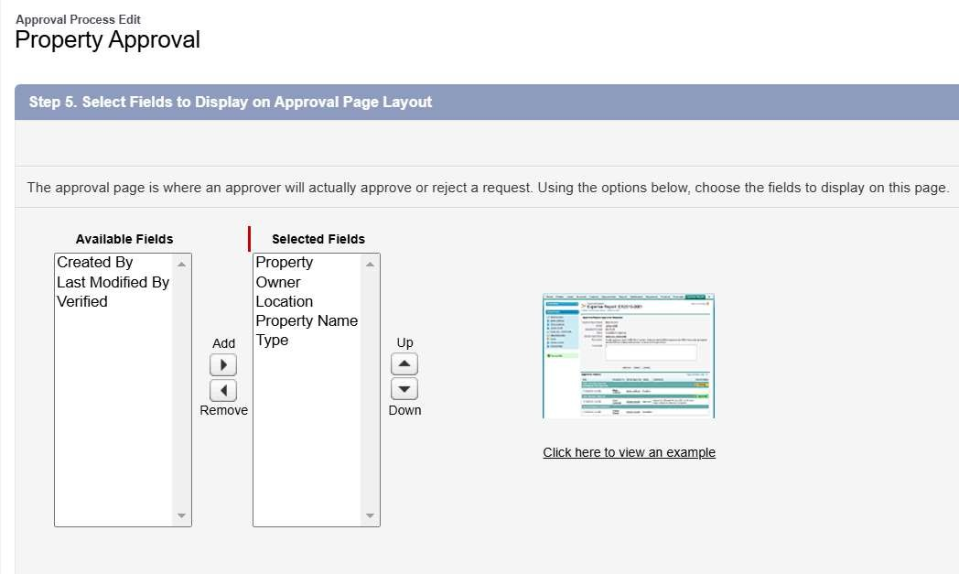**Create an Approval Process for Property Object**

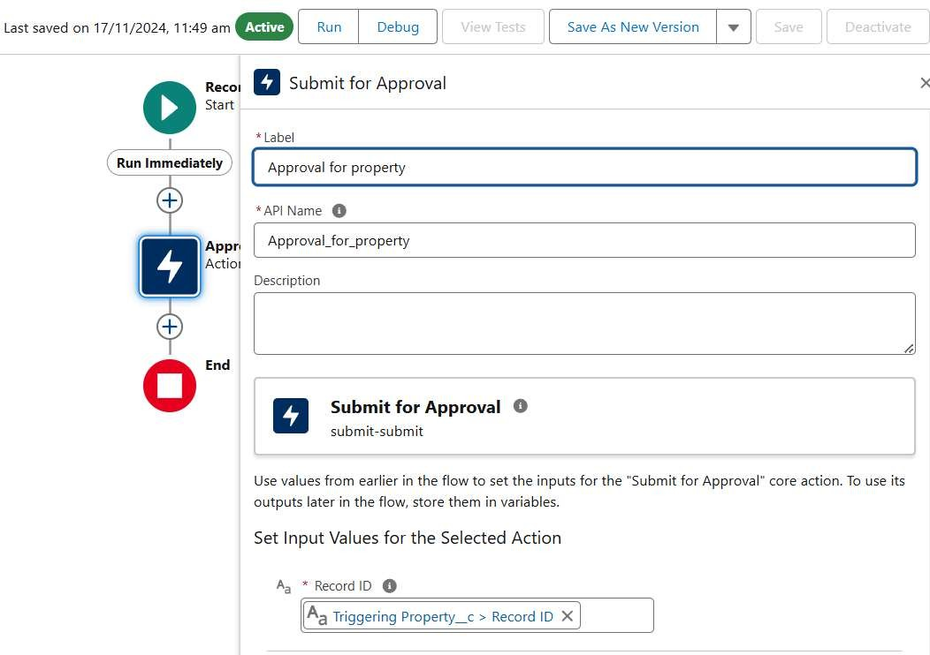**Create a Record trigger flow to submit the Approval Process Automatically**

**Create an App Page**

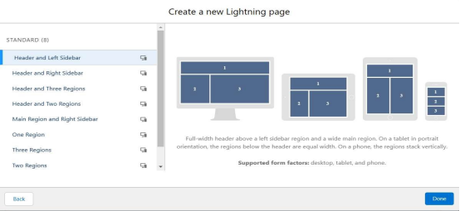

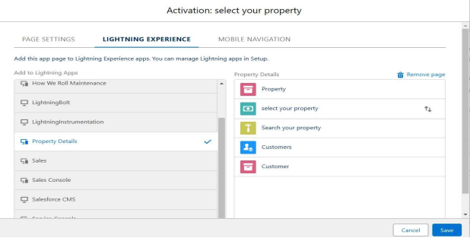

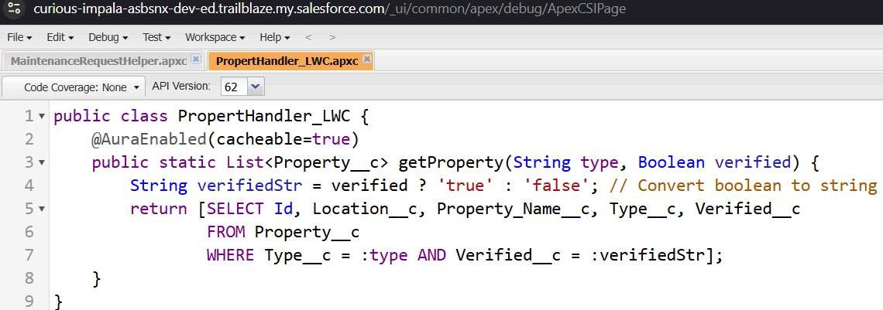**Create a LWC Component**

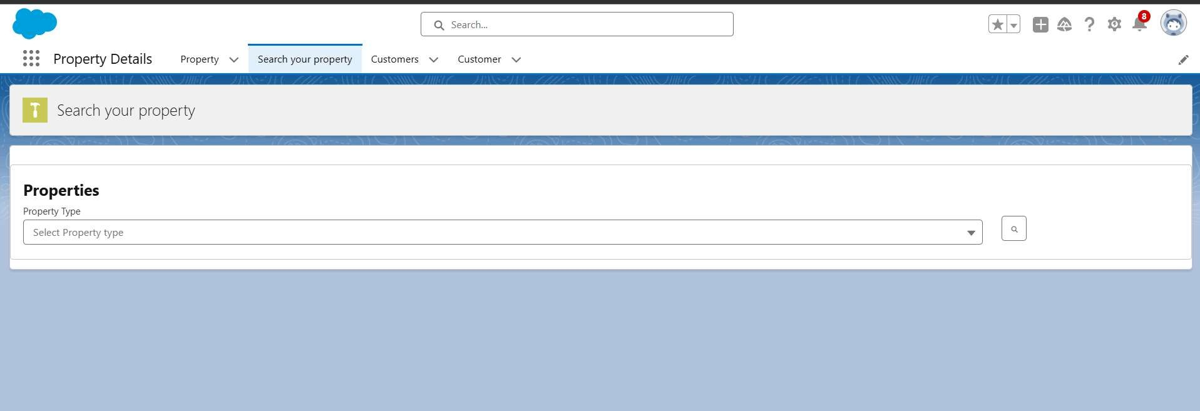**Drag this Component to your App Page**

**Give Access of Apex Classes to Profiles**

